To see the contexts:

kubectl config get-contexts

Create 3 clusters one hub and 2 spoke cluster:

eksctl create cluster --name hub-cluster --region us-east-1

eksctl create cluster --name spoke-cluster-1 --region us-east-1

eksctl create cluster --name spoke-cluster-2 --region us-east-1

After the three clusters are ready switch the context to the hub cluster so all the activities will be done on the hub cluster:

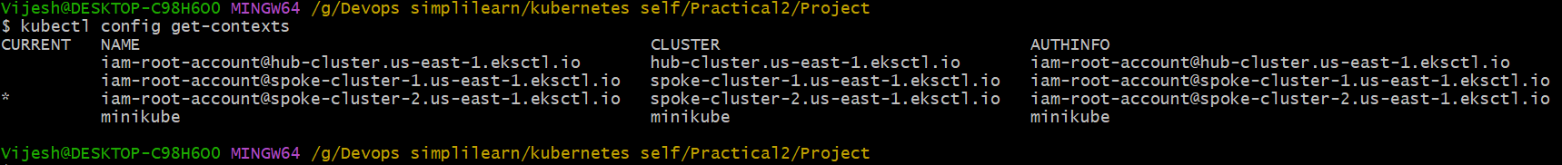

kubectl config use-context [iam-root-account@hub-cluster.us-east-1.eksctl.io](mailto:iam-root-account@hub-cluster.us-east-1.eksctl.io)

$ kubectl config get-contexts



Now setup argocd in hub cluster:

kubectl create namespace argocd

kubectl apply -n argocd -f <https://raw.githubusercontent.com/argoproj/argo-cd/stable/manifests/install.yaml>

Argocd cd can be run in two modes

443 – Secure mode using CA certiciates and keys

HTTP - Insecure mode

We will run in insecure mode using http for now.

To run in insecure mode edit the config map parameters:

## Run Argo CD in HTTP Mode(Insecure)

<https://github.com/argoproj/argo-cd/blob/54f1572d46d8d611018f4854cf2f24a24a3ac088/docs/operator-manual/argocd-cmd-params-cm.yaml#L82>

kubectl edit cm argocd-cmd-params-cm -n argocd

data:

server.insecure: "true"

Add the above snippet in the configmap at the end and save

To verify the above changes :

kubectl get deploy -n argocd

kubectl describe deploy argocd-server -n argocd

kubectl edit deploy argocd-server -n argocd

Change the argocd server service to nodeport from clusterip:

kubectl get svc -n argocd

kubectl edit svc argocd-server -n argocd

Now copy the port take the ip addres of any ec2 instance within the hub cluster and browse . This will open the argocd console:

Get the password from secrets:

kubectl get secrets -n argocd

kubectl edit secrets argocd-initial-admin-secret -n argocd

echo SWg4WnRpNXAzQ2NWV1VvVg== | base64 –decode



Now we have to add the other two clusters to the argocd using argocd command line, there is no such option from console. From console we can only delete.

Install Argocd CLI:

<https://argo-cd.readthedocs.io/en/stable/cli_installation/#installation>

for windows:

Add the other spoke clusters one by one:

Login into argocd using command line:

Try logging in from powershell else there is some issue with git bash

argocd login 44.197.102.49:32751

This is the ip address of the argocd console.

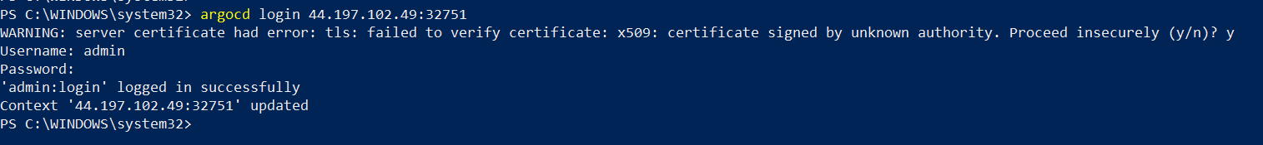



argocd cluster add iam-root-account@spoke-cluster-1.us-east-1.eksctl.io --server 44.197.102.49:32751

Add the second spoke :

Added both the clusters:

Now create two applications for both the clusters added, so that whenever any change happens in git it is reflected in both the clusters:

<https://github.com/vijeshnair89/argocd-hub-spoke-demo>

Now switch the context to both the clusters and the application should be visible:

kubectl config use-context [iam-root-account@spoke-cluster-1.us-east-1.eksctl.io](mailto:iam-root-account@spoke-cluster-1.us-east-1.eksctl.io)

Now to verify self healing, lets change some configuration in configmap of the spoke 2:

Tried to change the properties , but not able to change.



ui_properties_file_name: abhishek-interface.properties to

ui_properties_file_name: vijesh-interface.properties

Within the cluster not able to change now lets change from the git repository.

Wait for 3-4 minutes for auto sync to happen.

Sync successfully.

Delete the cluster:

eksctl delete cluster --name hub-cluster --region us-east-1

eksctl delete cluster --name spoke-cluster-1 --region us-east-1

eksctl delete cluster --name spoke-cluster-2 --region us-east-1

---------------------------------------Complete --------------------------------------------------------------